**Assignment 3**



**Table of Contents:**

Page 1: Title and logo

Page 2: Table of Contents

Page 3: Version history, Detailed Game Description, Controls, and Interface Sketch

Page 4: Screen Descriptions (Start State and Gameplay State)

Page 5: Screen Descriptions (Game-End State), Characters/Vehicles, Enemies, Scoring, and Sound Index

Page 6: Art / Multimedia Index

Page 7: All Assets Used

**Version History:**

Version 1 – November 19th 2015

**Detailed Game Description:**

Collect coins while you avoid the chests. The chests are after you because you are collecting their babies, you sick sick monster.

**Controls:**

WASD – Forward, left, back, right

Space – Jump

**Interface Sketch:** 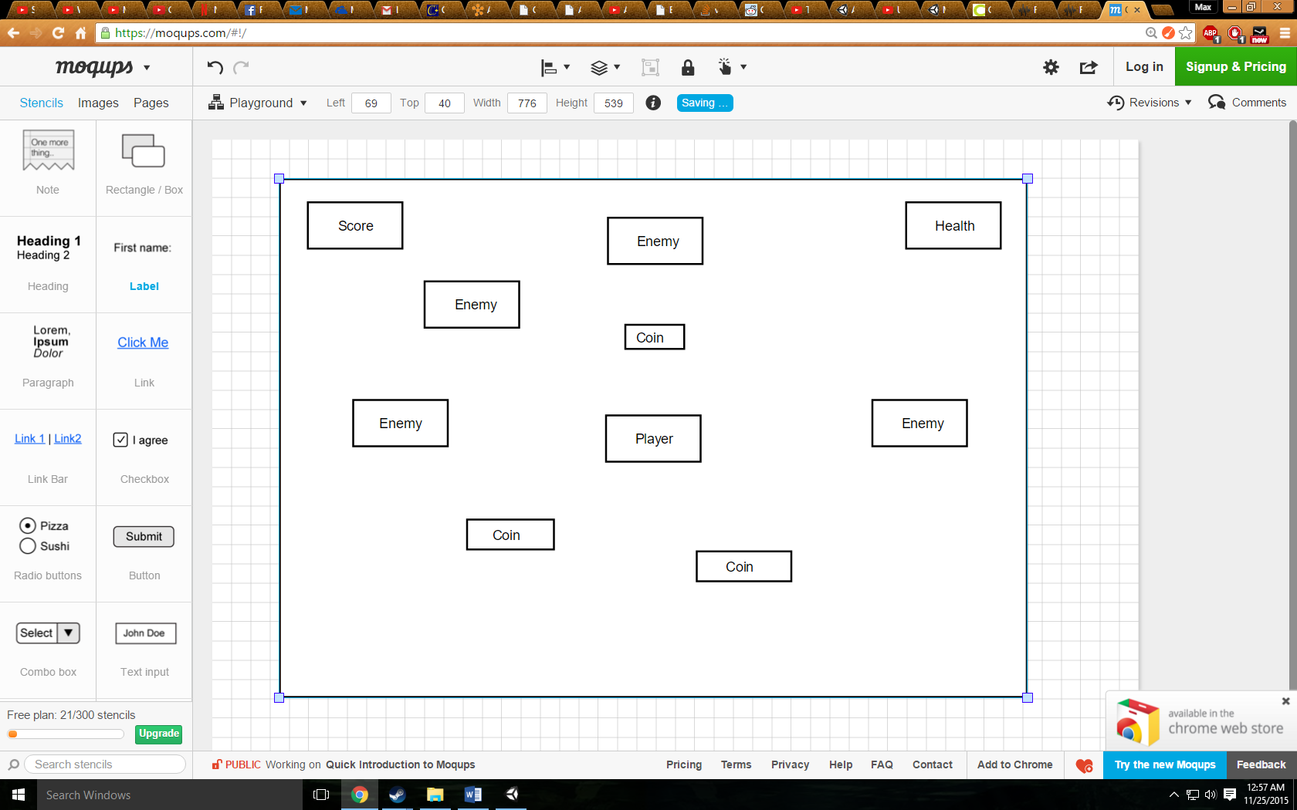

**Screen Descriptions:**

Start State:

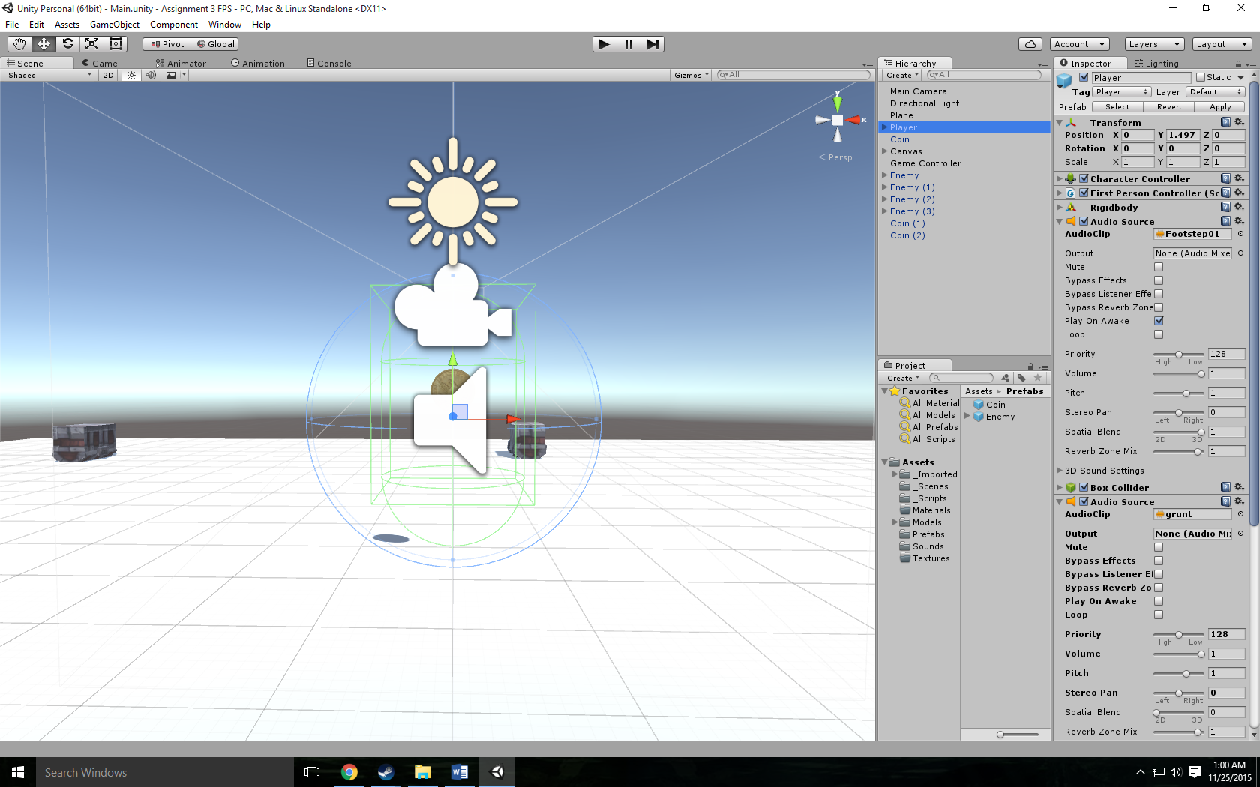

Gameplay State:

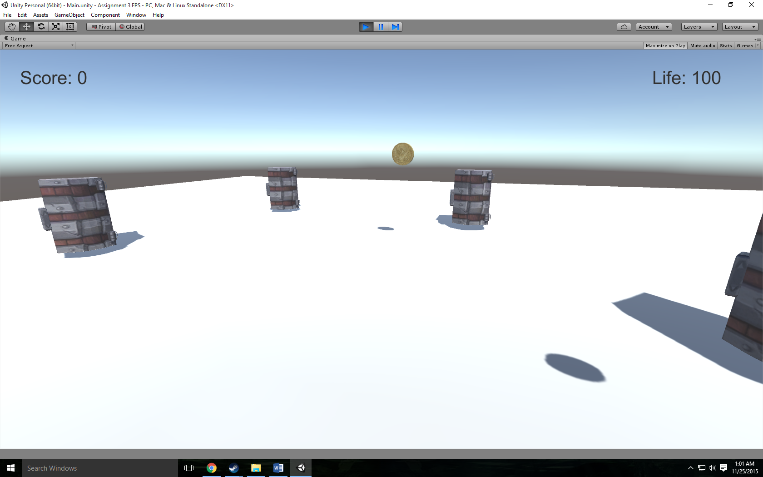

Game-End State:

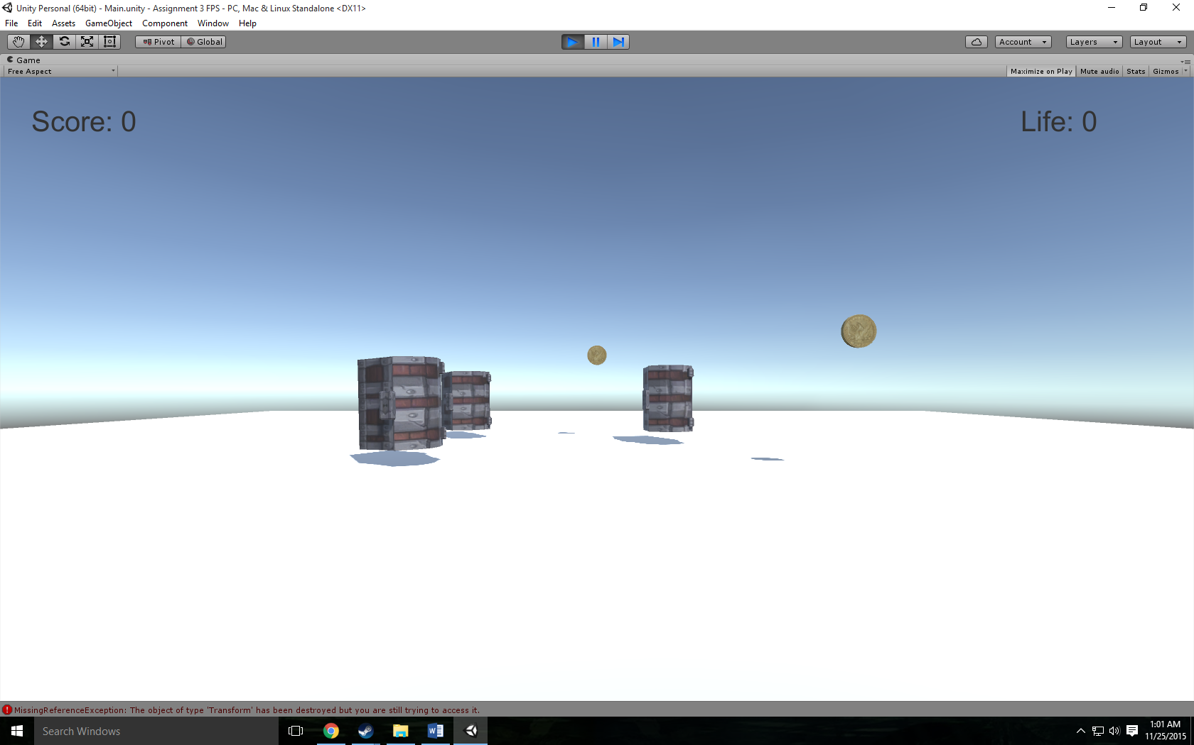

**Characters / Vehicles:**

Player – moves forward, back, and side to side.

**Enemies:**

Chest Enemy – constantly following the player.

**Scoring:**

100 points – Collect coin

**Sound Index:**

Grunt – Touch chest

Coin – Collect coin

Footstep – Walking

Jump – Jump

Land – Land

**Art / Multimedia Index:**

Coin Mesh:

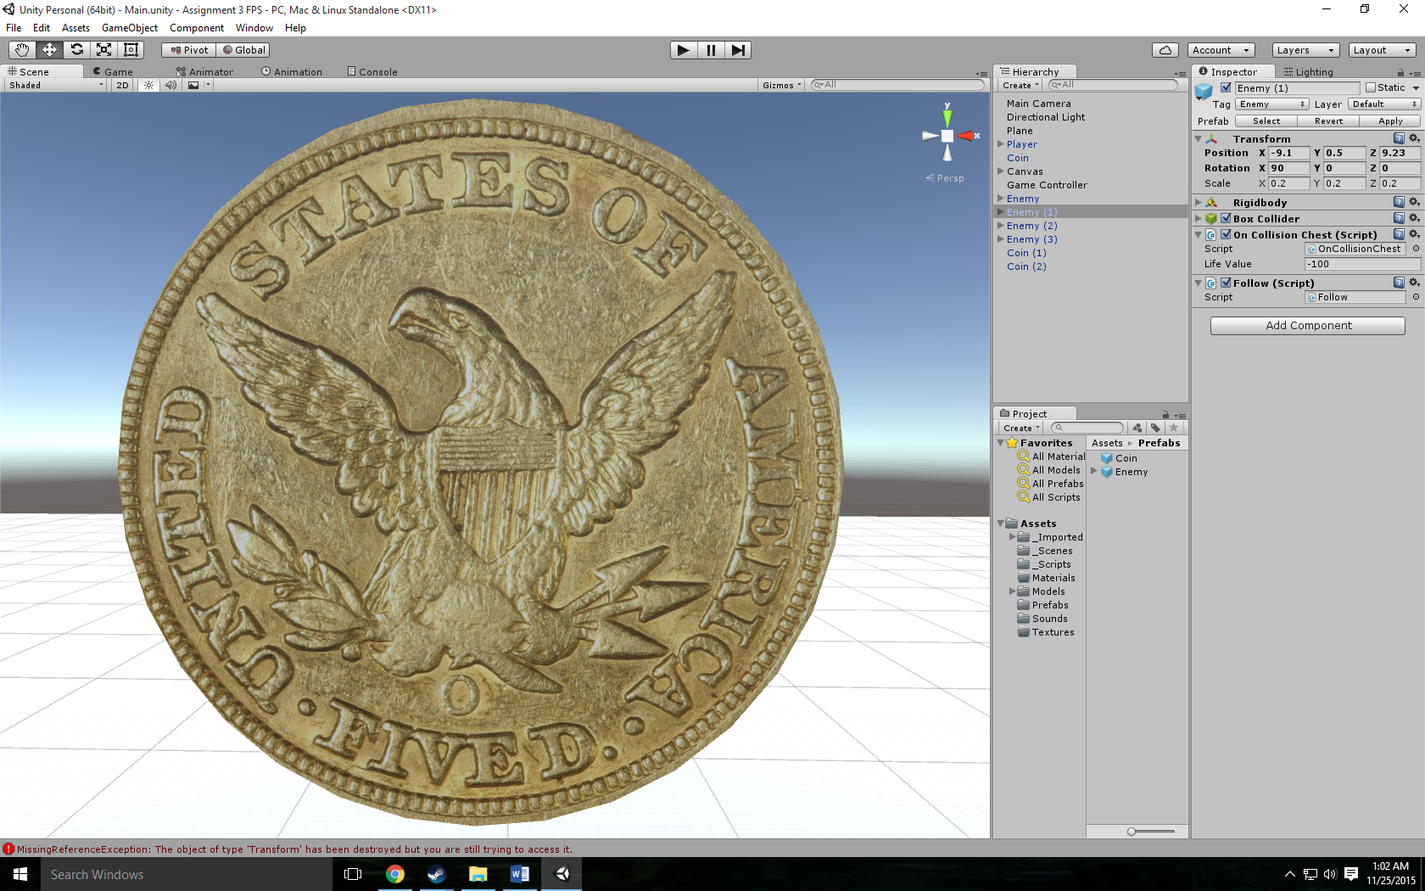

Chest Mesh:

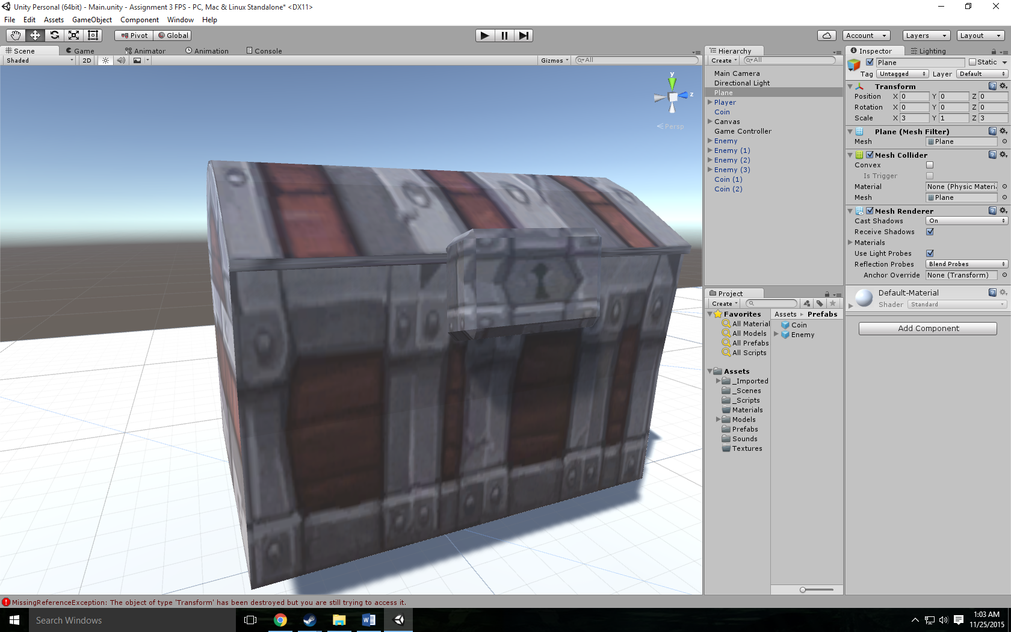

**All Assets Used:**

<http://tf3dm.com/3d-model/coin-4532.html>

<http://tf3dm.com/3d-model/cartoon-chest-29193.html>

<https://www.freesound.org/people/thecluegeek/sounds/140584/>

<https://www.freesound.org/people/DrMinky/sounds/166184/>

<https://www.google.ca/search?q=Chest+monster&espv=2&biw=1680&bih=949&source=lnms&tbm=isch&sa=X&ved=0ahUKEwj67rSY9KrJAhWTsh4KHeLcD2IQ_AUIBigB#imgrc=LXYxkF-McIoy4M%3A>